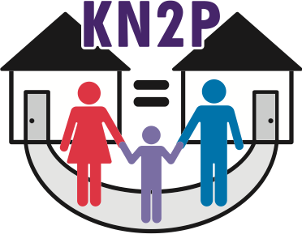
www.kn2p.org

WHITE PAPER TO SUPPORT SHARED PARENTING

- A 2008 UNICEF study ranked top 21 wealthiest countries on children’s well being. US received second worst ranking (20 of 21), citing divorce &
number of children being raised in single parent households as major risk factors.
- In 1995 America tied for first in world in college graduation rates. In 2006 US dropped to 14th & had second highest high-school dropout rate of 27 countries. Charlotte Observer, 3/12/10.
- 36% of American children in grades K-12 live without their biological fathers which leads to worse health & lower academic achievement. Stanford U., 2007.
- 85% of primary physical custody still goes to women. Census Bureau, 2006.
- “Children in father-absent homes are 5 times more likely to be poor.” Census Bureau, 2002.
- In Meck. County 34,000 children live in poverty. Charlotte Observer, 9/25/09.
- Half of all families in poverty are those with female-headed household & no husband at home. Census Bureau, 2002.
- “Three thousand or more Charlotte children are homeless on any given night.” Charlotte Observer, 3/13/09.
- “Fatherless children are twice as likely to drop out of school.” US Dept. of HHS, 1993.
- Children from fatherless homes account for 71% of all high school dropouts. The father gets custody only in about 15% of divorce cases. Florida International University, 2009.
- The NC high school graduation rate is now 72%. Charlotte Observer, 10/24/08.
- Fatherless children are at a dramatically greater risk of drug & alcohol abuse, mental illness, suicide, poor educational performance, teen pregnancy, & criminality. US Dept. of HHS, 1993.
- Three out of 4 teenage suicides occur in households where a parent has been absent. The Christian Century, July 1993.
- “Older boys & girls from female-headed households are more likely to commit criminal acts than peers who live with 2 parents.” Social Psych. Quarterly, 1996.
- Adolescents from single-parent families engage in greater & earlier sexual activity. Journal of Behavioral Medicine, 1994.
- “The economic consequences of a father’s absence are often accompanied by psychological consequences, which include higher levels of youth suicide, low intellectual & educational performance, & higher-than-average rates of mental illness, violence, & drug use.” Progressive Policy Institute, 1993.
- “Kids who exhibited violent behavior at school were 11 times as likely not to live with their fathers.” American Journal of Public Health, 1994.
- In the U.S. there are 10 million single mothers living with children under 18—three times as many as in 1970. Parade, 5/2/10.
- “Fathers who share parenting are the most likely to pay child support, spend additional money on their kids, & contribute to college educations.” Research brochure by Dr. Linda Nielsen, Wake Forest University, 2008.

